February 5, 2021
By Esayas Temesgen
We had enough … fake news, cool it.

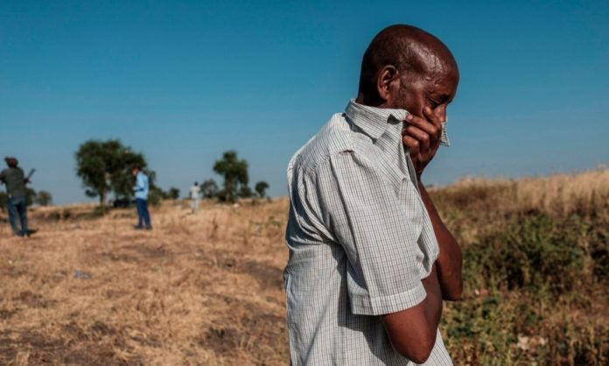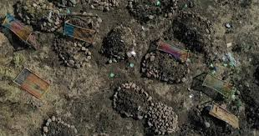
This days we are getting a lot of fake news about the situation in Ethiopia. As it is known at the moment Ethiopian government is in a hunt of the medieval mob, who did an imaginable crime against humanity on Ethiopians and neighboring countries for almost three decades.
Moreover recently it’s heinous act on the military in their sleep to overthrow the government and carried out a genocide on a particular nationality, Practiced wide spread ethnic cleansing and made a run to attack Neighboring Eritrea.
This being the truth of the matter, Claiming entitlement of global supremacy bunch of white fox supported by western media such as the BBC and Reuters, are in a crusade of Intimidation and false accusation with the title of “former this and former that….”
All of a sudden these lobbyist found their way back to harassing and bulling Eritrea. Who they consider their punching bag. In their mission for the last three decades to disrupt the horn and set it for wretchedness. Which they couldn’t succeed except in Somalia, with the help from this medieval mob that they are lobbing for at present.
It is disgusting that these individuals predominantly White brazen attitude to disregard the Junta’s heinous crime; years of project to breakup Ethiopia and simultaneously attacking Eritrea to disturb the peace between the two counties dreading Eritrea’s objectivity-
In this part of the horn these lobbyist are so frustrated, because they run into a buffer that they can’t penetrate: i.e. two functioning governments tug teaming not at each other throat unlike the “failed” states which they are aspiring for.
In one hand fearfully independent Eritrea that they tried for decades and failed to push around; on the other - new Ethiopia that they can’t figure out since they are no more in control.
To their surprise they are shunned out by the new Prime Minister and stopped from meddling in the internal affairs of autonomous states. as they do in the “ failed states” like in Libya; Syria; Somalia; Yemen; Iraq etc.
The countries they breakup and kept it miserable and label it as a “failed state” so that they can toy with it. Leaving the citizens in desperation and destitute out of reach of their own country. And eventually forced to abandon it exposing themselves to human traffickers.
these lobbyist will come back on the other end as savior: decorating themselves with attractive names like: NGO; this group for Africa; that group for Red Sea and so on and so forth to have humanitarian cover to solicit fund and secure their business of meddling.
Let us be frank, what pains these the so-called former “ambassadors” …is that Eritrea saved Ethiopia from the brink of collapse and unpredictable civil war.
As a result they couldn’t bank on the chaos crying “humanitarian crises “line up as a “NGO” and invite all these global vultures.
Which they would label Ethiopia as a “failed State” and get back in business, cashing - in working for Cable and nightly news, on CNN and The BBC etc.…as the Horn specialist, commentator on Africa - showing a footage of human fleet of refugees and people on bread line dwelling under a blue plastic roof.
This egocentric white technocrats luck the moral authority to push around African leaders. Things ought to change.
Aping the ante the western media spread flood of fake news stating that the State Department emailed to this media to that media, he said she said without proof.
I believe the US State Department recognizes there is a functioning government in Ethiopia which has nothing but praise for Eritrean government and people; unwavering support during the crises. Otherwise if there was any complaint we would have heard it from the government appropriately.
Actually the US have a new Ambassador in Ethiopia, Her Excellency Ms. Greeta Pasi as US government representative
The Ambassador has communicated her understanding of the current situation in Ethiopia: that the medieval mob has initiated the war on Ethiopia government and people furthermore commented on the reckless nature of the Junta’s era of administration and unbounded corruption.
In retrospect Reuter and the BBC are not interested in this truth. They are in the business of destruction, cover-up and blunt lie. They want us to skip the Elephant in the room and look for a needle in the hay stack.
The Junta propagandist fake news peddlers [Digital Weyane ] most of whom are in North America and Canada, has no bound for their hate of Eritrea: they make an outrageous claim of lie like Looting. The truth of the matter it is the Junta that is known for looting; corruption and killing.
In the first place that is why the Ethiopian government is hunting it as an outlaw criminal to bring it to Justice.
This Medieval Mob that loot Eritrea; bombed churches; desecrate Eritrea’s martyrs’ cemetery and committed other crimes during it’s envision of Eritrea.
in Tigray before it run out of Mekele to its cave in Temben Mountain not only looted but destroyed factories; buildings; churches, Mosques; air ports and bridges, generators etc.
After ransacked the pharmaceutical factory vandalize the factory and left.
Emptied all the Banks in Tigray: robbed all the dollar, local currency as well as gold.
Another fake news is Eritrean soldiers patrolling Mekele;
Rather what we saw on TV is Ethiopian Special Forces and the Federal police patrolling and going house to house looking for material the Junta stole including cache of fire arms, and yes the Junta’s higher ranking officers who were hidden under women skirt.
I mean renegade Generals handcuffed, which the Ethiopian TV displayed live for the public and the world to see. And interviewed the Ethiopian force who are patrolling Mekele city.

As recently as this week the Ethiopian government was able to break in the fake news network. The army captured one of the scam bag in Southern Ethiopia trying to escape to Kenya through Moyale, Ethiopia.
He admitted that he has been paid US $600.00 a month, to spread lies on internet such as … “capturing Ethiopian generals and killing some of them; destroying this division that Brigade and about Eritrean soldiers.”
He even gave the name of the person who lives in North America that he worked for $600 a month. This proofs the medieval mob tentacle is global.
those on the Junta’s payroll particularly in North America and Europe as complicit to the crime is going to be handled by the Interpol the international police network; which is now involved in the Mai- kadra genocide case.
For the reason that:
One; the money was stolen directly from Bank of Ethiopia and liquidation of other Ethiopia’s wealth.
Two: the money used to hire fake news propagator to cover its crime against humanity, looting and money laundering.
Spewing fake news to change the narrative against these glaring evidence is futile.
These picture are so powerful and a vivid massage to the world to put the Junta and its accomplices in a global wanted list. It will remain in the memory until the medieval mob and their accomplice brought to Justice and be held to the highest extent of the law.
As for the international lobbyist they can’t undermine the peace that endowed a Nobel peace prize and such an important breakthrough for the citizens of both countries with a great historical significance.
Peace between ERITREA AND ETHIPIA has a historical, Political and Economic importance for the region as well, as a result it has bear fruit in a trial - run in such a short period of time.

Black live matters!
Awet n’ hafash!

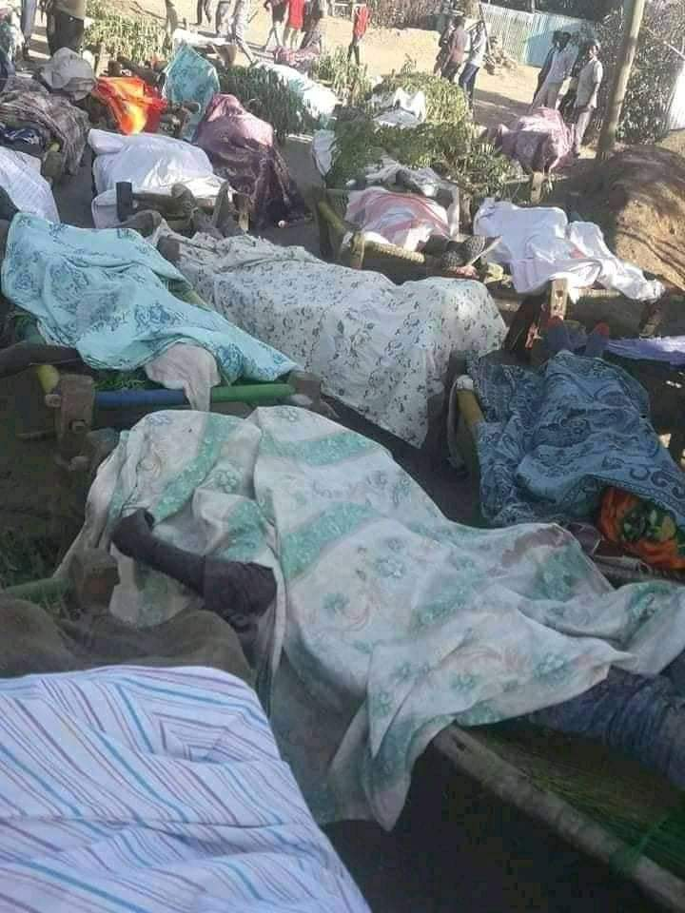
MASS GRAVE
A person sobbing covering his nose from the strong Odor while overlooking of mass grave of massacred Ethiopian civilians by Junta killing squad in mai-kadra, Ethiopia.
Overlooking
This is the reality on the ground what the fake news don’t want the WORLD TO SEE. Justice will prevail!
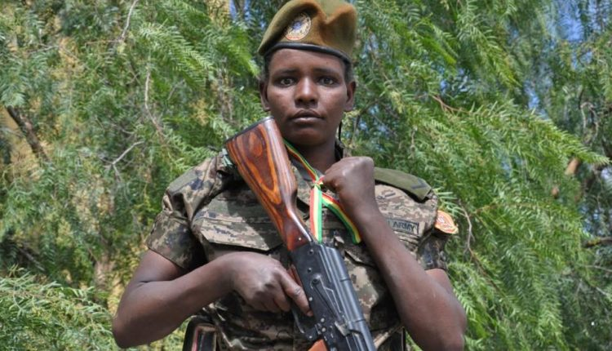
Brave Ethiopian Female soldier: who arrested a Junta colonel from his hideout in the bathroom, where she found him commanding the killing squad in her camp, forced him to surrender his pistol and escorted him to Eritrea a ten hour trek; until her regiments arrive.

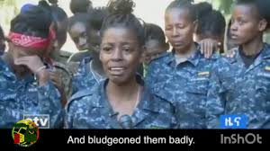
Group of Ethiopian Female solders survivors of brutal torcher by the mob, crying while recounting horrific torture and killing of their comrades to a local Journalist: their neck and breast cut with machete and
Their private part knifed and mutilated to death by the Medieval Mob. AND themselves

